**Lab report #10**

**Sadovskaya Veronika**

Because Parallel is designed to optimize and speed up big data, a table with 1 million records was created for this lab. Because query results are cached, the table was dropped and recreated for each query.

**Task 1 - CREATE Example of Select Parallel execution**

1. Select without parallel:

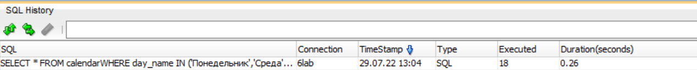

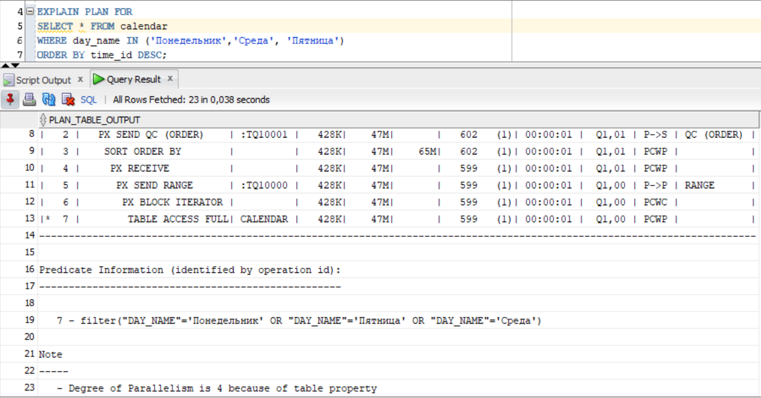

2)Select with parallel:

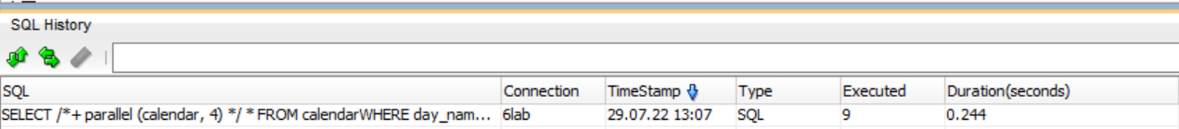

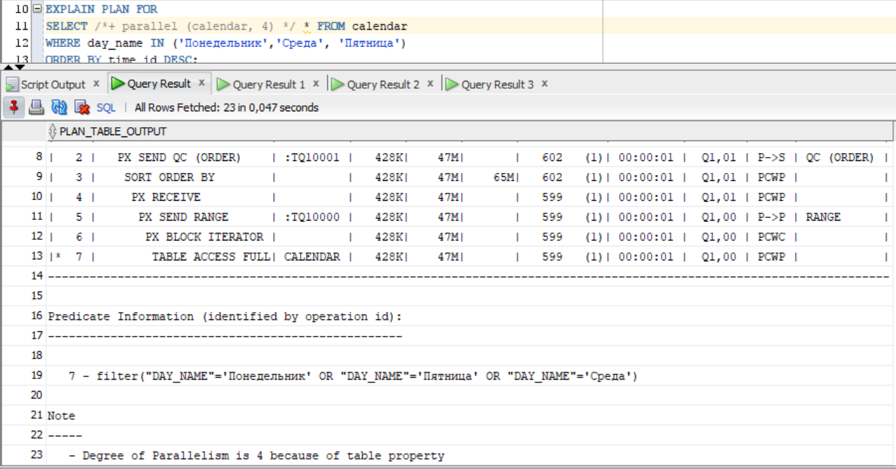

As we can see from the results, the query execution time with parallel is less by 0.016 seconds, which almost does not matter. If we look at the execution plans for both queries, we can see that they are identical, that is, when fetching large amounts of data, Oracle itself chose a parallel without being explicitly indicated using hints.

**Task 2 - CREATE Example of Parallel  DML**

1. Without parallel DML

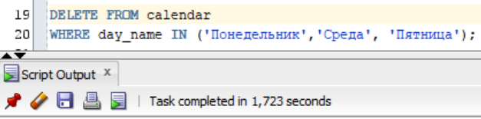

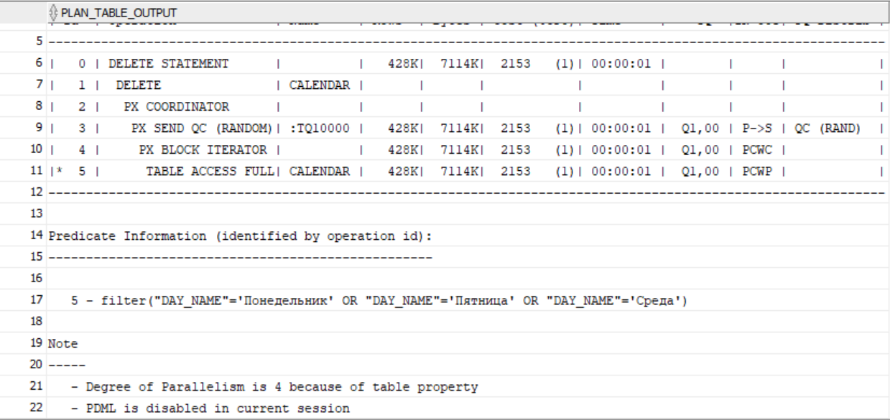

1. With Parallel DML

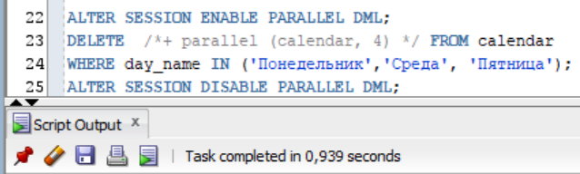

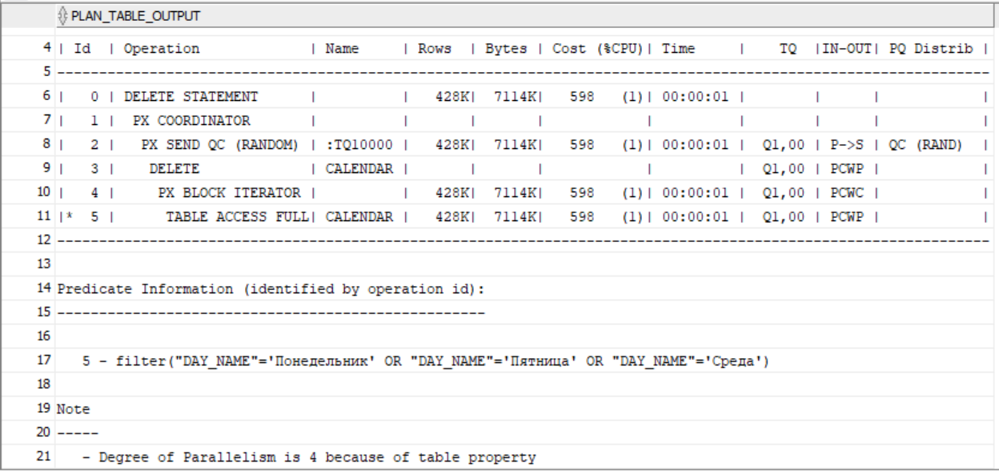

As we can see, the execution time of a query using parallel is less than half that of a query without parallel. Query plans differ only in the presence of PDML in the current session.

**Task 3 - CREATE Example of Parallel  DDL**

1. Without parallel DDL

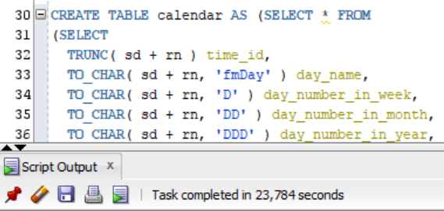

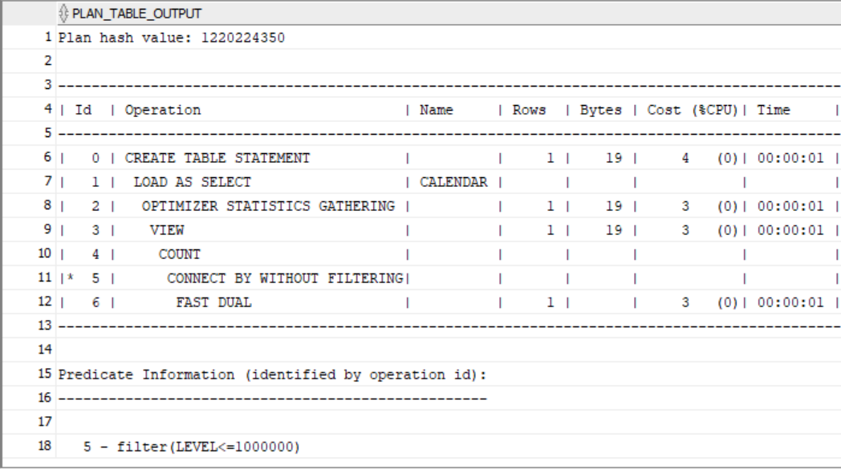

1. With parallel DDL (hint)

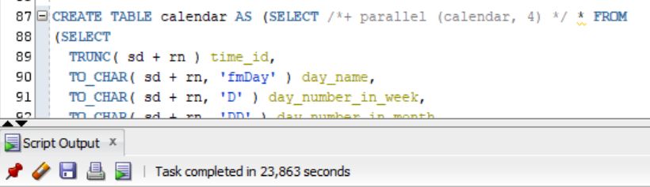

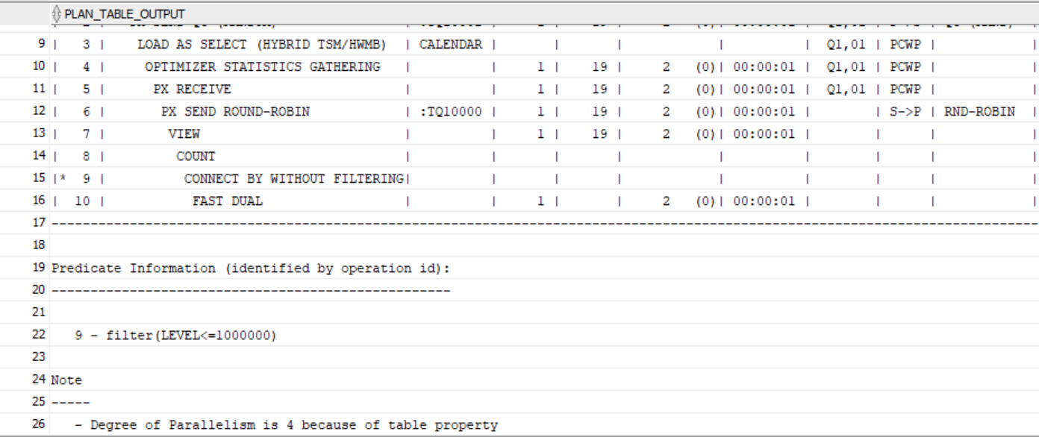

1. With parallel DDL (PARALLEL command)

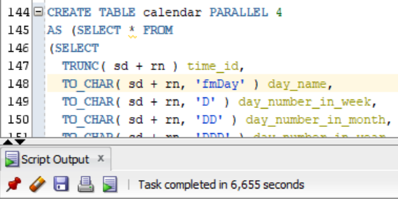



As you can see from the query results, the query that runs the fastest is using the PARALLEL command.

The small amount of data, the parallelization does not improve the results. To benefit from parallel query execution, you need to work with a large amount of information.

**Task 4 - CREATE Strategy of Parallel execution**

The use of parallelism can be a good example of increasing the speed and efficiency of a data warehouse.

Since I have tables in my data warehouse that need to be constantly updated or new data added, such as ORDER_FACT, CLIENT_DIMENSION, EMPLOYEE_DIMENSION, it makes more sense to use the DML parallel to run this process more efficiently at the DW, CL, and SA levels.